XXXXXXXXXXXXXXXXXXXXXXXXXXXXXXXXXXXXXXXXXXXXXXXXXXXXX

XXX Aluna: Gina Szajnbok Harari

XXX TIA: 72008075 - CURSO MESTRADO EM CIÊNCIAS DA COMPUTAÇÃO

XXX Universidade Presbiteriana Mackenzie

XXXXXXXXXXXXXXXXXXXXXXXXXXXXXXXXXXXXXXXXXXXXXXXXXXXXX

**Tarefas da Semana**

**De 11/06 a 18/06**

**- Planejamento da metodologia para a elaboração da Ontologia**

**- Utilização do Prótegé**

**De 19/06 a 25/06**

**- Execução da formatação dos textos de apoio.**

**Tarefas dos Dias**

**De 26/06 a 28/06**

**- Inclusão de Data Proprieties e Execução da formatação dos textos de apoio. Testes com o Software FAR – Find and Replace.**

**De 29/06**

**- Execução da formatação dos textos de apoio.**

**Planejamento da metodologia para a elaboração da Ontologia**

1. **Motivação Histórica.**

Selecionar e verificar a existência de Ontologistas ao longo da história.<Ontologistas.docx> Ex. Spinoza, Russel.

1. **Seleção do texto básico sobre COVID-19para produzir os Objetos, Classes, e Propriedades da Ontologia:**

BMJ best Practice COVID-19. **BMJ Publishing Group Ltd. 2020**, London. Disponível em:

<https://bestpractice.bmj.com/topics/en-gb/3000168/pdf/3000168/Coronavirus%20disease%202019%20%28COVID-19%29.pdf>. Acesso em: 17 de jun. de 2020.

Resultado: 97 palavras.

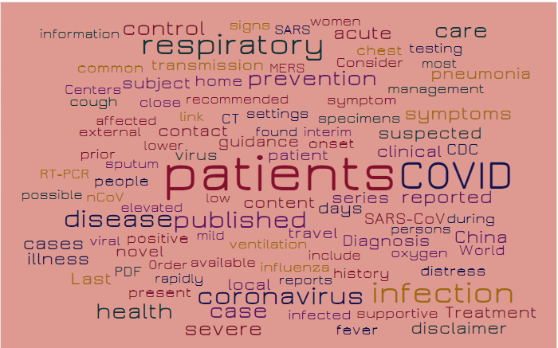

Possible patients guidance content published found patient interim travel ventilation days settings recommended low virus contact include influenza prevention onset specimens symptom local home transmission available respiratory clinical series mild coronavirus SARS-CoV link case infected positive Diagnosis disease history Consider COVID suspected severe Order SARS elevated sputum chest rapidly people lower acute close oxygen management symptoms control reported external MERS present infection health distress novel viral support ive women affected signs CT subject CDC prior during cough nCoV pneumonia most testing PDF care China common fever Centers reports persons disclaimer cases World illness Last Treatment RT-PCR information

1. **Seleção de textos de apoio1.αβγδεζηθικλμνξοπρςστυφχψω**

Os textos de apoio serão retirados das seguintes fontes:

1. Referências bibliográficas da apresentação do Pré-Projeto da Dissertação da Disciplina de Metodologia de Trabalho Científico. (O Pré-Projeto possui 123 referências, o que tornou inviável para esta entrega. Na apresentação do Pré-Projeto foram selecionados os textos mais atuais e relevantes). <Apresentação_projeto_V14.pdf>, quais sejam:

\_

**1 Observação importante**: Percebeu-se, por causa dos textos serem científicos, que eles possuem *stopwords* próprios. Após alguns testes com os textos selecionados, percebeu-se que alguns deles, embora científicos, não serviram como base para a criação da Ontologia, mas tão somente como texto de apoio, pois o objetivo do texto não era conceitual e sim procedural, com execuções e resultados. Percebeu-se também que algumas *stopwords* eram válidas ou não, dependendo de textos específicos, como por exemplo, a palavra “**others**” **não é** *stopword* para o texto de FERRAZ e MONTEIRO (2019). Isto porque o texto trata de “morte por outras causas”. No entanto ela é *stopword* para o texto de CHANG (2020), pois é um pronome comumente utilizado. Isto foi analisado em todos os textos de apoio para que não fosse imposto um viés na API do WordItOut. Percebeu-se também a necessidade de inclusão de símbolos matemáticos nas *stopwords.*As letras gregas, comumente utilizadas nos textos matemáticos também foram consideradas *stopwords.*

**- Trabalhos seminais em epidemiologia**

KERMACK, W. O.; MCKENDRICK, A. G. A contribution to the mathematical theory of epidemics. Proceedings of the Royal Society of London. Series A, Containing papers of a mathematical and physical character, The Royal Society London, v. 115, n. 772, p.700–721, 1927.

Resultado: 98 palavras

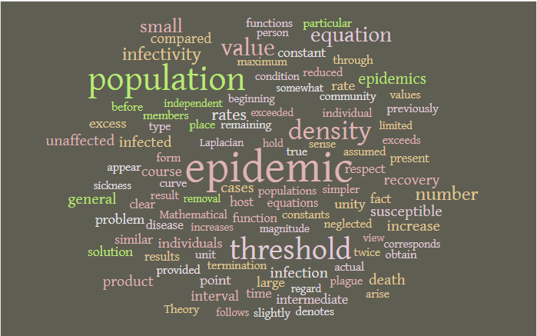

Epidemic population threshold density value equation numbers mall infectivity rates epidemics recovery infected product cases susceptible infection unaffected increase death general course interval compared rate unity individuals point excess problem host similar time fact constant solution larger espect intermediate function results disease equations present clear values reduced result individual true neglected appear particular curves members denotes unit actual previously populations community through before slightly obtain provided constants remaining place maximum assumed simpler exceeds termination twice plague form arise Theory functions Mathematical obtained whether lead identical consider used raw sickness difficulty independent regard discussion complete obtaining previous contact chance

**- Trabalhos recentes em epidemiologia, Sistemas Dinâmicos, *OSN (Online Social Network),* Teoria dos Jogos (Revisão Sistemática), Base de Dados**

CHANG, Sheryl L. et al. Game theoretic modelling of infectious disease dynamics and intervention methods: a review. Journal of Biological Dynamics, v. 14, n. 1, p. 57-89, 2020

Resultado: 95 palavras

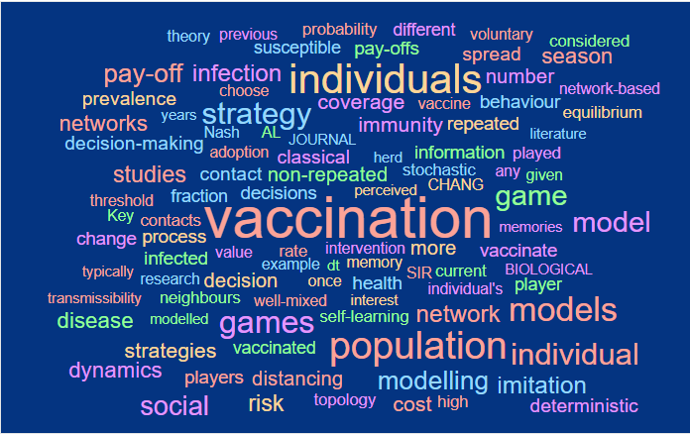

Theory vaccination perceived non-repeated intervention memory classical example health JOURNAL interest decisions self-learning once more herd immunity coverage rate population stochastic well-mixed strategy information SIR decision games contact adoption current individuals CHANG vaccinated fraction network individual's distancing susceptible repeated vaccinate infection modelling value process pay-offs game BIOLOGICAL Nash neighbours vaccine studies topology AL any contacts modelled models individual infected memories given risk probability years different high players behaviour played number previous social decision-making literature spread research change pay-off strategies voluntary dynamics choose transmissibility imitation prevalence equilibrium model dt cost Key network-based networks threshold player deterministic

FAN, D. et al. Novel fake news spreading model with similarity on PSO - based networks. Physica A: Statistical Mechanics and its Applications, Elsevier, p. 124319, 2020.

Resultado: 97 palavras

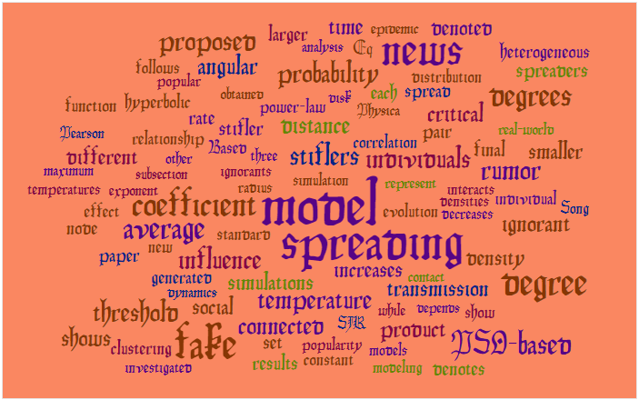

Model simulation spreading stiflers radius distances imulations ignorants three standard individuals represent temperature evolution increases power-law coefficient influence Based correlation stifler obtained transmission disk Physica probability connected while social pair product popularity news analysis each critical fake generated spread relationship average sub section rate angular larger densities other depends interacts proposed models final dynamics constant decreases hyperbolic set density distribution modeling individual popular ignorant clustering threshold degrees new rumor Eq denoted PSO-based contact results time papers how exponent spreaders smaller effect investigated denotes follows different degree Song function shows epidemic real-world node SIR temperatures maximum Pearson heterogeneous

MISTRY, Dina et al. Inferring high-resolution human mixing patterns for disease modeling. arXiv preprint arXiv:2003.01214, 2020.

Resultado: 93 palavras

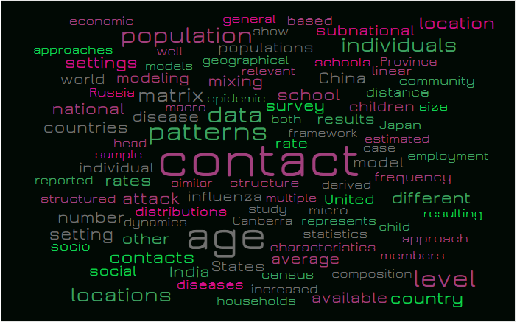

Contact structure patterns multiple data study both rate Canberra influenza epidemic mixing age similar survey framework derived distributions relevant micro school characteristics represents disease attack statistics matrix results geographical State saverage populations population modeling model China children census increased show United schools models case house holds India individuals estimated available contacts individual general diseases dynamics rates subnational other distance frequency head locations based countries different child composition sample settings linear Japan social number national setting members Russia approach resulting approaches well reported macrolevel structured country employment economic world Province size community socio location

**- Trabalhos recentes efetuados na UPM**

FERRAZ, D. F.; MONTEIRO, L. H. A. The impact of imported cases on the persistence of contagious diseases. Ecological Complexity, v. 40, p. 100788, 2019.

Resultado: 74 palavras

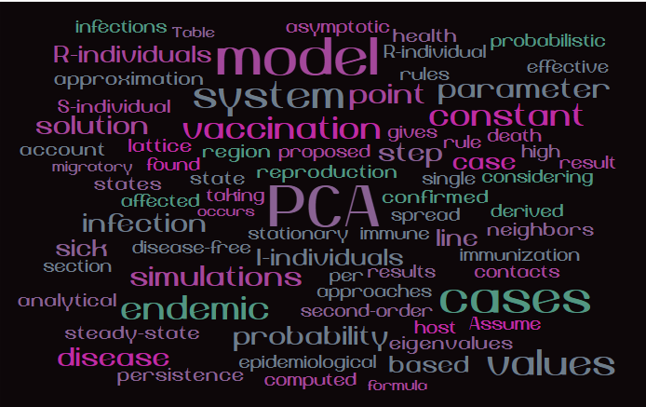

PCA reproduction stationary I-individuals proposed vaccination per taking system approaches second-order immune region simulations step results confirmed model point probability occurs epidemiological disease-free gives spread endemic state single affected infection line constant based found case rules R-individual immunization asymptotic cases steady-state health R-individuals parameter eigenvalues persistence derived computed approximation host neighbors disease contacts states considering lattice Assume solution rule values probabilistic analytical S-individual formula effective high Table migratory sick result infections section account death

MONTEIRO, L. H. A.; CHIMARA, H. D. B.; BERLINCK, JG Chaui. Big cities: shelters for contagious diseases. Ecological Modelling, v. 197, n. 1-2, p. 258-262, 2006.

Resultado: 99 palavras

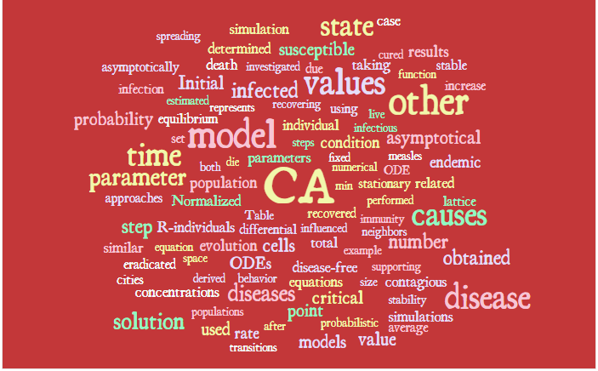

CA parameters recovered steps influenced model differential Table individual condition numerical fixed min total cells disease-free recovering population ODEs values stationary Normalized die evolution equation simmunity performed neighbors infectious using R-individuals both represents infected example behavior live critical asymptotical investigated ODE parameter equilibrium diseases supporting related susceptible number time other Initial point derived equation estimated due death determined space contagious endemic taking causes state stability probabilistic concentrations simulation models after rate cured value populations simulations set disease eradicated step lattice obtained probability size solution transitions asymptotically function results used case approaches similar spreading average cities infections table increase measles

MORAES, A. L. S.; MONTEIRO, L. H. A. On considering the influence of recovered individuals in disease propagations. Communications in Nonlinear Science and Numerical Simulation, v. 34, p. 224-230, 2016. – utilizado como consulta.

Resultado: 100 palavras

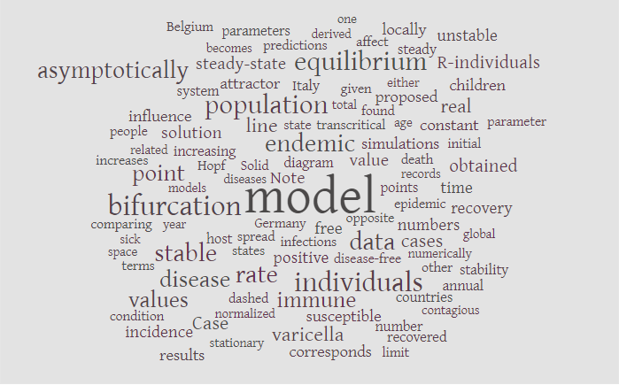

Model diagram Germany Note endemic infections diseases opposite positive Solid line transcritical population disease-free state rate spread individuals data immune simulations total value bifurcation points states increasing attractor Italy records epidemic host numbers stable given found dashed equilibrium susceptible varicella steady-state cases solution numerically death normalized disease Hopf models proposed free age predictions system parameters point influence obtained constant time year corresponds countries number derived either related stationary contagious real Case recovery affect other becomes initial stability comparing asymptotically global values locally children steady R-individuals sick one annual Belgium recovered people results increases incidence condition terms limit un stable space

SCHIMIT, P. H. T.; MONTEIRO, L. H. A. A vaccination game based on public health actions and personal decisions. Ecological Modelling, v. 222, n. 9, p. 1651-1655, 2011.

Resultado: 91 palavras

**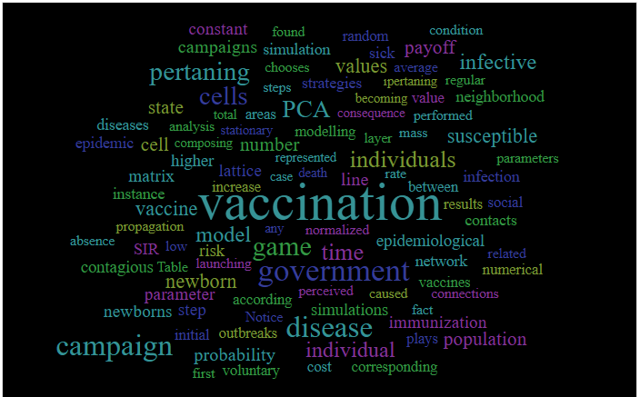**

Vaccination normalized death represented line case time number government modelling individuals game perceived PCA any increases imulations model lattice consequence epidemiological stationary rate becoming layer disease launching according areas strategies mass between cells individual caused higher chooses composing network vaccines values newborn Notice outbreaks total simulation steps pertaining parameter analysis performed results pertaining immunization low step probability vaccine infection Table value corresponding sick random fact susceptible voluntary found cost risk average instance propagation contacts matrix plays cell campaigns population state constant payoff initial condition neighborhood related connections regular infective SIR numerical parameters campaign epidemic newborns social absence first diseases

1. Será incluído na análise o seguinte texto recém publicado:

MONTEIRO, L. H. A. An epidemiological model for SARS-CoV-2. Ecological Complexity, p. 100836, 2020.

Resultado: 97 palavras

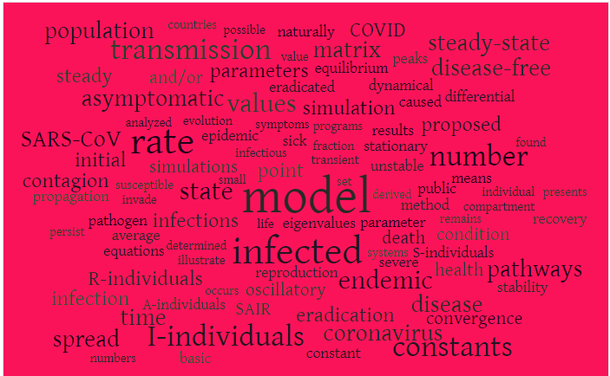

Model eigenvalues point infected transient infectious sick symptoms programs values fractions imulation small reproduction oscillatory infections state eradicated eradication parameter stationary parameters unstable imulations endemic derived epidemic determined death results illustrate SAIR equilibrium matrix coronavirus I-individuals method occurs set rate public transmission dynamical caused number if asymptomatic S-individuals proposed remains constant naturally disease COVID R-individuals and/or evolution disease-free A-individuals equations condition constants analyzed susceptible average time peaks severe means steady-state differential contagion possible individual compartment health pathways pathogen found basic spread invade population stability initial convergence SARS-CoV infection propagation persist value systems recovery steady numbers countries presents

1. **Metodologia para a formalização das classes, subclasses, membros e propriedades**

**4.1 Contagem de palavras**

Uma API 2 será utilizada para contagem de palavras para verificar as palavras mais utilizadas em todos os textos compactados no arquivo [Seleção de todas as palavras dos textos - cada texto eh uma coluna.xlsx](Seleção%20de%20todas%20as%20palavras%20dos%20textos%20-%20cada%20texto%20eh%20uma%20coluna.xlsx) e posteriormente essas palavras serão pesquisadas no texto básico e se transformarão em classes e as relações serão efetuadas manualmente via análise das classes e subclasses.

Serão utilizados os seguintes **limites máximos** como característica da Ontologia:

**52** classes e subclasses,

**33** propriedades para cada classe/subclasse 3.

* 1. **Ferramenta 5W4H**

Será aplicada a ferramenta **5W4H** para cada elemento elencado pelo software, usando a seguinte transformação:

– WHAT -> o quê – “Classes, subclasses e membros” (Objeto)

– WHY -> Por quê – “Propriedades” (Justificativa)

– HOW -> Como fazer - “Propriedades” (Estratégia)

– WHEN -> Quando - “Propriedades” (Unidade temporal)

– WHERE -> Onde - “Propriedades” (Localização Geográfica)

– HOW FEEL -> Para quê - “Propriedades” (Resultados esperados)

– WHO -> Para quem - “Classes, subclasses e membros” (Público Alvo)

– HOW MUCH -> Quanto - “Propriedades” (Unidade de valor)

– HOW MEASURE -> Como medir - “Propriedades” (Monitoramento, controle, parametrizações)

2 Worditout (<https://worditout.com/word-cloud/create>)

3 Número passível de modificação, conforme o desenvolvimento da tarefa.

* 1. **Exemplos**

Exemplos gerais do 5W4H:

1. (WHAT) Coronavirus disease 2019 (COVID-19) - is a - Severe acute respiratory infection **[Subclasses]**
2. (HOW) Coronavirus disease 2019 (COVID-19) – was caused by - severe acute respiratory syndrome coronavirus 2 (SARS-CoV-2) **[proprieties]**
3. (WHERE) Coronavirus disease 2019 (COVID-19) – was started - in Wuhan City, Hubei Province, China **[proprieties]**
4. (WHEN) Coronavirus disease 2019 (COVID-19) – was started - in December 2019 **[proprieties]**
5. (WHAT) Middle East respiratory syndrome (MERS) – is a - Respiratory infection **[Subclasses]**
6. HOW MUCH) - Respiratory infection – has as a cause – a mild common cold-like illness **[proprieties]**
7. (HOW MUCH) - Respiratory infection – has as a cause - a severe viral pneumonia that is potentially fatal **[proprieties]**
8. (WHO) SARS-CoV-2 - is the name of - the virus owing to the virus's genetic similarity to the SARS-CoV vírus disease spectrum **[proprieties]**
9. (HOW MEASURE) Disease spectrum - is diferent than - SARS-CoV vírus disease **[Subclasses disjuntas]**
10. (HOW MEASURE) Disease transmission – is diferent than - SARS-CoV vírus disease **[Subclasses disjuntas]**

**Utilização do Prótegé**

1. **Criação de Classes, Subclasses, Propriedades, Subpropriedades, membros e anotações no Software Protégé.**

****

1. **Execução de testes iniciais (somente com algumas classes).**

**